C:\Users\heather\AppData\Local\Microsoft\Windows\Temporary Internet Files\Content.IE5\WE623Z7T\MC900356443[1].wmf

**Fun June Recipes:**

**Ingredients:**  
1 cup sugar  
1 cup of water  
1 pint fresh strawberries  
1 cup fresh lemon juice (about 8 whole lemons)  
4-6 cups cold water (this will vary depending on your taste)

**Fun June Recipes:**

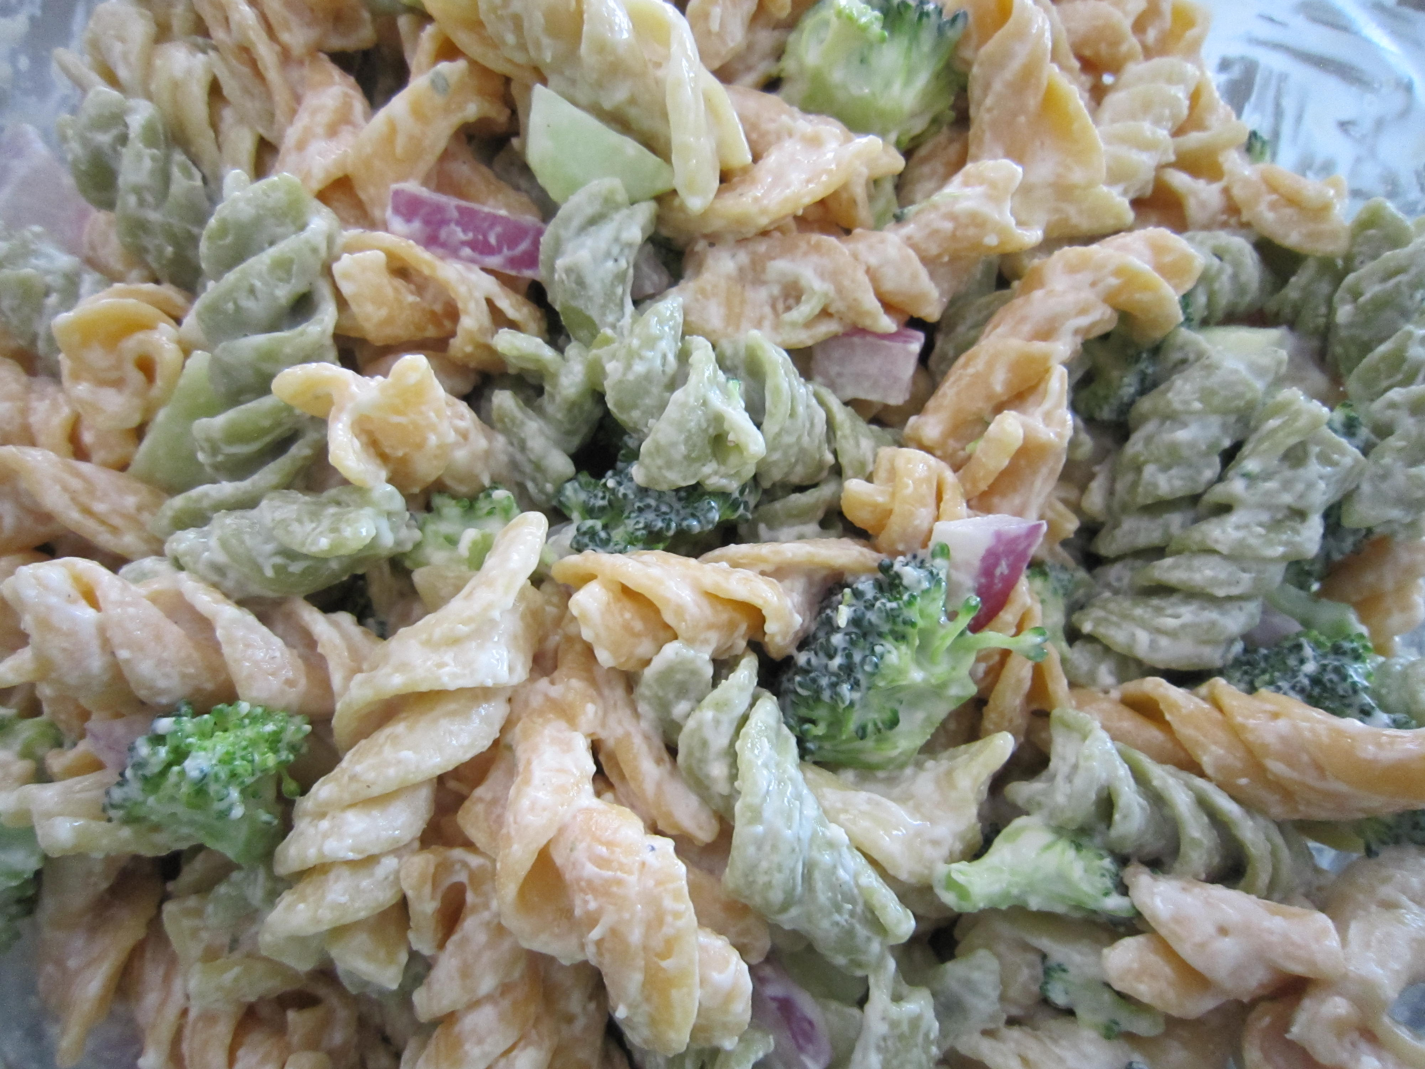

**Ingredients:**  
1 cup Greek yogurt  
1/4 cup Miracle Whip  
1 packet (+ additional depending on your taste) ranch dressing mix  
1 lb spiral pasta, cooked  
2 large carrots  
1 1/2 cups broccoli  
1 cup Cheddar cheese   
1/2 yellow bell pepper  
1/2 red bell pepper

**What’s coming up:**

June 14th, 2014: Flag Day   
June 15th, 2014: Father’s Day   
June 21st, 2014: First day of Summer

**Shelter Creek Contact us:**

Monday- Friday 9:00 AM-6:00 PM  
Saturday-Sunday 10:00 AM-5:00 PM

Phone Number: (408) 297-4675  
Fax Number: (408) 297-0524  
Website: [www.sheltercreekapts.com](http://www.sheltercreekapts.com)  
Email:sheltercreek@cascoproperties.com

Fun Activities for June:

Go to the beach! We live near some of the most beautiful beach sites. Take a 30minute drive to Santa Cruz or Capitola.

Or take a drive down the peninsula to beautiful Monterey or Carmel California!  
In Monterey visit the amazing Monterey bay aquarium.

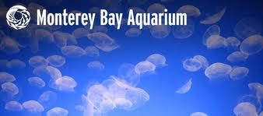

**Fun Events in June:**

* 5/30/14-6/1/13- San Jose Greek Festival, Located at 1260 Davis St. San Jose, CA



* June 18th, 2014 International Picnic day

