



### The First Thanksgiving

t

Shelter Creek Apartments

In 1621 the Pilgrims had a good harvest and were thankful that they had made it to the New World and were actually surviving and prospering.

In order to celebrate all of their gifts and good luck the Pilgrims decided to have a harvest festival and a day of thanks. They celebrated with venison, fowl, fresh vegetables, and maybe some pumpkin desserts. Also, the day was made up of sports, conversing with friends, and simply resting after a long harvest. The Indians were invited to also share in the festival and many of them did.

The original Thanksgiving was not as much of a religious day as it was a festival of thanksgiving. This day of thanks for all of their blessings resulted in the appropriate name for the holiday: Thanksgiving.

Traditional Thanksgiving Menu:

Easy Roasted Turkey

Delicious Heb Stuffing

Traditional Sweet Potatoes

Creamy Mashed Potatoes

Savory Turkey Gravy

Thanksgiving Newsletter

The first American Thanksgiving was celebrated in 1621, to commemorate the harvest reaped by the Plymouth Colony after a harsh winter. In that year Governor William Bradford proclaimed a day of thanksgiving. The colonists celebrated it as a traditional English harvest feast, to which they invited the local Wampanoag Indians.

### A New National Holiday

By the mid–1800s, many states observed a Thanksgiving holiday. Meanwhile, the poet and editor Sarah J. Hale had begun lobbying for a national Thanksgiving holiday. During the Civil War, President Abraham Lincoln, looking for ways to unite the nation, discussed the subject with Hale. In 1863 he gave his Thanksgiving Proclamation, declaring the last Thursday in November a day of thanksgiving.

In 1939, 1940, and 1941 Franklin D. Roosevelt, seeking to lengthen the Christmas shopping season, proclaimed Thanksgiving the third Thursday in November. Controversy followed, and Congress passed a joint resolution in 1941 decreeing that Thanksgiving should fall on the fourth Thursday of November, where it remains.









Individual Highlights:

Dad’s News Page 2

Mom’s News Page 3

Kids’ News Page 4

North Carolina produced 1.2 billion pounds of sweet potatoes in 2012, more than any other state.

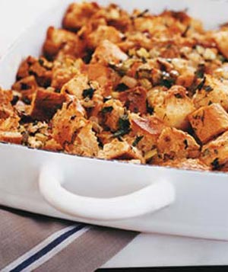

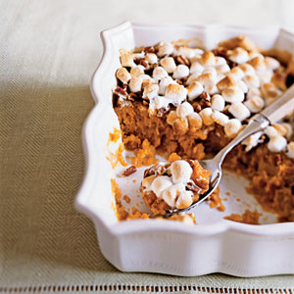

2 1/2 pounds sweet potatoes, peeled and cut into 1-inch cubes **Click to see savings**

3/4 cup packed brown sugar

**Click to see savings**

1/4 cup butter, softened

**Click to see savings**

1 1/2 teaspoons salt

1/2 teaspoon vanilla extract

1/2 cup finely chopped pecans, divided

Cooking spray

**Click to see savings**

2 cups miniature marshmallows

**Click to see savings**

**Preparation**

Preheat oven to 375°.

Place the sweet potatoes in a Dutch oven, and cover with cold water. Bring to a boil. Reduce heat, and simmer for 15 minutes or until very tender. Drain; cool slightly.

Place potatoes in a large bowl. Add sugar and next 3 ingredients (through vanilla). Mash sweet potato mixture with a potato masher. Fold in 1/4 cup pecans. Scrape potato mixture into an even layer in an 11 x 7-inch baking dish coated with cooking spray. Sprinkle with remaining 1/4 cup pecans; top with marshmallows. Bake at 375° for 25 minutes or until golden brown

Traditional Sweet Potatoes

Delicious Herb Stuffing

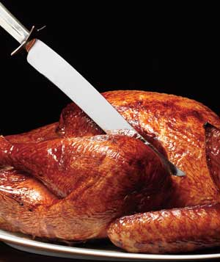



Page of 3

Serves 6-8| Hands-On Time: 25m| Total Time: 1hr 00m

### Ingredients

* 3 cups low-sodium chicken broth
* 3/4 cup (1 ounce) dried porcini mushrooms, roughly chopped (optional)
* 2 tablespoons olive oil or unsalted butter
* 2 medium yellow onions, diced
* 1 1/2 teaspoons kosher salt
* 3/4 teaspoon black pepper
* 2 stalks celery, diced
* 3/4 cup fresh flat-leaf parsley leaves, finely chopped
* 2 tablespoons chopped fresh dill
* 1 1/2 baguettes, left on the counter overnight to dry and cut into 1/2-inch pieces (10 cups)

### Directions

1. In a saucepan, bring the broth and mushrooms (if using) to a boil. Remove from heat. Meanwhile, in a large skillet, over medium-low heat, heat the oil or butter. Add the onions, salt, and pepper. Cook for 8 minutes. Add the celery and cook for 7 minutes. Add the parsley and dill.
2. Heat oven to 375° F. Place the bread in a large bowl. Add the onion mixture and the broth and mushrooms (if using) and combine. Transfer to a 9-inch square or 11-by-7-inch baking dish or the cavity of the turkey (see Tip below).
3. Bake the stuffing for 25 minutes. If you prefer a soft stuffing, cover the dish with foil while baking. If you prefer a crusty stuffing, bake uncovered. (You can cover and refrigerate the uncooked stuffing for up to 24 hours. Bake as directed, adding 10 minutes to the baking time.)

Easy Roasted Turkey

**Ingredients**

* 1 12-pound turkey, thawed if frozen
* 12 sprigs fresh thyme
* 2 medium onions, cut into wedges
* 2 tablespoons unsalted butter, at room temperature
* kosher salt
* 2 carrots, cut into 2-inch pieces
* 2 stalks celery, cut into 2-inch pieces
* 1 cup low-sodium chicken broth (if needed)

**Directions**

1. Heat oven to 375° F. Working on a baking sheet, remove the giblets and neck from the cavity. Reserve the neck and discard the giblets. Using a paper towel, pat the turkey dry of juices. Stuff with the thyme and half the onions.
2. Tie the legs together with kitchen twine. Tuck the wing tips underneath the body (this will prevent them from burning).
3. Rub the turkey all over with the butter and season with 1 teaspoon salt, making sure to reach the crevices of the legs and wings. Be careful not to tear the delicate skin.
4. Place the turkey neck, carrots, celery, and remaining onions in a large flameproof roasting pan. Put a roasting rack in the pan and place the turkey on top of it.
5. Roast the turkey, basting every 30 minutes with the pan juices. (Basting will not make the meat moister, but it will produce an evenly browned skin.)
6. If the turkey begins to darken and there is still a substantial amount of cooking time left, tent it loosely with foil. If the vegetables begin to scorch, add some broth to the pan.
7. Continue roasting until the thickest part of a thigh registers 165° F, 2½ to 3 hours. Tilt the turkey to empty the juices into the pan. Transfer the turkey to a carving board, tent with foil, and let rest for at least 25 minutes.

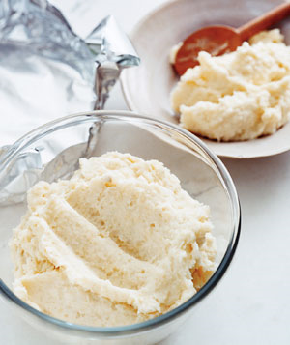

**Ingredients**

1 cup dry white wine

* 1 to 3 cups low-sodium chicken broth
* 4 tablespoons (1/2 stick) unsalted butter
* 1/3 cup all-purpose flour
* kosher salt and black pepper

### Directions

Remove the vegetables and neck from the roasting pan; discard. Carefully strain the pan juices into a fat separator. Let stand 5 minutes, allowing the fat to rise to the top. Pour the juices into a large measuring cup, leaving the fat behind.

Place the empty roasting pan across 2 burners over medium-high heat. Add the wine and cook, scraping up the brown bits stuck to the pan, for 1 minute.

Pour the contents of the pan into the measuring cup of skimmed juices. Add enough chicken broth to make a total of 4 cups of liquid.

Melt the butter in a large saucepan over medium heat. Sprinkle with the flour to create a roux.

Cook the roux, whisking frequently, until deep brown, 4 to 5 minutes. Keep in mind that the darker the roux, the richer the flavor.

Whisk in the 4 cups of liquid and bring to a boil. Reduce heat and simmer until thickened, 8 to 10 minutes.

Season the gravy with ¾ teaspoon salt and ¼ teaspoon pepper. Strain just before serving. (If you do it any earlier, a skin will form on the surface of the gravy.)

2050 Southwest Expressway

San Jose, Ca 95126

Phone:

408-297-4675

Fax:

408-297-0524

E-Mail:

sheltercreek@cascoproperties.com

Savory Turkey Gravy

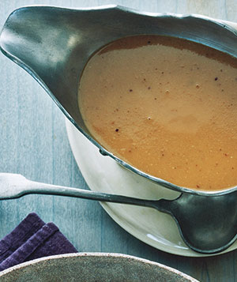

Serves 6-8| Hands-On Time: 20m| Total Time: 35m

**Ingredients**

5 pounds white or Yukon gold potatoes, peeled and cut into 2-inch chunks

2 1/2 tablespoons plus 1 teaspoon kosher salt

12 tablespoons unsalted butter, cut into pieces, at room temperature

1/2 to 3/4 cup heavy cream

1 cup [sour cream](http://www.realsimple.com/food-recipes/ingredients-guide/sour-cream-00000000039369/index.html)

1/4 teaspoon ground nutmeg

3/4 teaspoon black pepper

**Directions**

Place the potatoes and 2½ tablespoons salt in a large pot. Cover with cold water. Bring to a boil. Reduce heat and simmer until tender, 20 to 25 minutes. Meanwhile, in a saucepan, over medium heat, heat the butter and ½ cup of the heavy cream until the butter melts.

Drain the potatoes and return to pot. Add the butter-cream mixture, sour cream, nutmeg, pepper, and the remaining salt. With a handheld potato masher, mash the potatoes. If a thinner consistency is desired, add the remaining cream, 1 tablespoon at a time.

Transfer the mashed potatoes to a heatproof serving dish.

# Creamy Mashed Potatoes

Page of 3

A favorite family phrase or slogan can go here.

We’re on the Web!

Visit us at:

[www.sheltercreekapts.com](http://www.sheltercreekapts.com)